Information Security 2 Final Test Review

Zero Conditional

Rewrite the following as zero conditional sentences

1. If you open this file, the virus will download

If you open this file, the virus downloads. (3인칭)

2. When a worm gets into your network, it will be hard to detect





Connect the events with cause-effect sentences

1. Click anywhere on the webpage

2. The malware downloads

3. Your computer crashes frequently

4. Data is lost

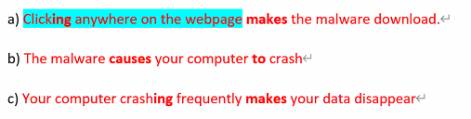

Past Continuous 

Answer the questions using the past continuous:

1. What were you doing last night?



2. Where was she studying last week?



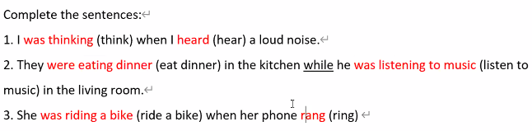

Rewrite the two events in one cause-effect sentence using “so… that…” or “such… that…”

Cause: I downloaded a big file / Effect: My computer crashed

I downloaded a so big file that my computer crashed.

Cause: The class was really interesting / Effect: I didn’t go to sleep

The class was so really interesting that I didn’t go to sleep.

Cause: There were many students / Effect: They made two classes

There were such many students that they made two classes.

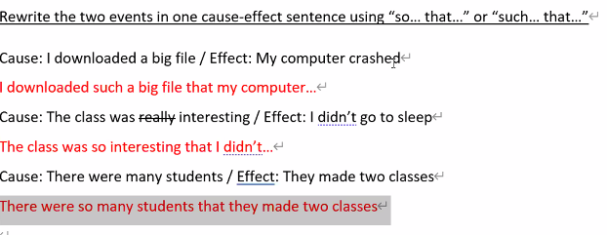

Language Focus: Cause and effect 2

**Structure: so… that…**

Pattern: 

Examples: I was so sleepy that I couldn’t study [Cause: I was sleepy / Effect: I couldn’t study]

My sister is so shy that she never talks [Cause: My sister is shy / Effect: She never talks]

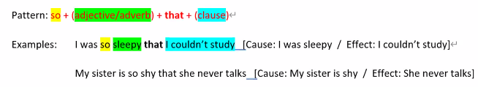

**Structure: such… that…**

Pattern: _________________________________________

Examples: [Cause: It was a great movie / Effect: I watched it many times]

It was such a great movie that I watched it many times!

[Cause: Jill is a great teacher / Effect: Everybody loves her]

Jill is such a great teacher that everybody loves her. 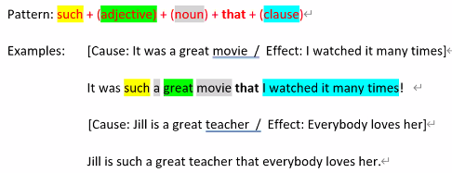

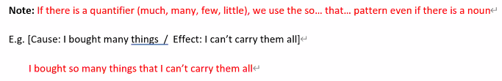

Practice: so…that…

1. [Cause: James is very tall / Effect: James can touch the ceiling]

James is so very tall that James can touch the ceiling.



1. [Cause: He speaks too loud / Effect: The baby can’t sleep]

He speaks so loudly that the baby can’t sleep

1. [Cause: The virus is very dangerous / Effect: If you get it, you will lose all your data]



Practice: such…that…

1. [Cause: She is an intelligent girl / Effect: She always gets A+]



She is so intelligent that she always….

1. [Cause: The island is an amazing place / Effect: The island has many visitors every year]



1. [Cause: We have strong internet security / Effect: No hacker can attack us]



Developing Software

Put these stages of the software development process in order:

5

The customer checks and approves the final version

Speak with the people who will use the new software and analyse how they will use it.

1

Plan the project, write the specifications and prepare instructions for the programmers.

2

Test and debug the code

4

Write the code

3

Reading:  
Read the interview from Computer World, an online magazine, in which Jess Wong, a systems analyst, talks about her job. Which of the stages above does she mention?

|  |
| --- |
| Interface specification process client pop-up developers flow charts changes step |

CW: So, Jess, could you tell us about the requirements analysis prosess?

JW: First, we talk to the client to find out who the users will be. Then we interview as many users as possible. This can be difficult because we have to look at every step in the process in a lot of detail.

CW: And what’s the next step ?

JW: Next, we make the specification document. This shows everything that the program does. We have to write down what every button does, what will appear on every pop-up enu, and so on.

CW: Is this where you draw flow charts ?

JW: Yes, and the user Interface.

CW: And does the client check the specification document?

JW: Yes. We need the client to be happy with it. We usually have to make some changes at this stage but it is usually quite quick. Then we give the project to the developers so they can start programming.

Comprehension:

1. Why does Jess talk to the client at the beginning of the process?
2. Why are the interviews sometimes difficult?
3. What is in the specification document besides writing?
4. Why does the analyst want the client to check the specification document?

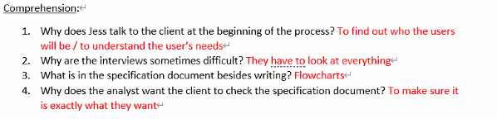

Vocabulary: Match these words with their definitions

|  |  |
| --- | --- |
| Approve ( C)  Analyse ( B)  Debug ( E)  Detail (A)  Interview ( Dx) | All the separate features and pieces of information about something  Think about something very carefully; step-by-step  Officially say you are happy with something  Ask someone questions to find out information  Find problems in a computer program and fix them |

~~Listening:~~

~~Listen to a systems analyst talking to a worker. He is preparing specifications for a pizza shop website to take orders online. Which stage in the process is he at?~~

~~Listen again and complete 1-4 in this flow chart~~

1. ~~Ask which type of standard pizza. 3~~
2. ~~Ask which toppings. 2~~
3. ~~Customer wants standard pizza? 1~~
4. ~~Write order on order sheet. 4~~



Listen again and complete 5-8

1. Ask for delivery address. 6
2. Customer wants another pizza? 5
3. Calculate delivery time. 7
4. Tell customer deliver time. 8

Label the flowchart. Which one doesn’t appear on the flow chart?

* Terminal symbol – start/End (circle, rectangle with rounded corners)
* Input/Output – Paeallelogram
* Process – Rectangle
* Initialization/Preparation
* Decision – Diamond

-----------------------------------------------------------------------------------------------------------------------------------

Make the flowchart for the following virus checking process:

First, the program should ask the user if they want to run scan the whole computer or target certain drives/folders.

If the user chooses a targeted scan, they need to select which drives/folders they want to scan.

Next, the scan should start

Once the scan is finished, any files containing viruses are automatically deleted.

At the end of the process, the AV program should close.

~~Programming Code~~

~~Listening:~~

~~Listen to the programmers talking about this code which controls a robot by using a mobile phone. Number the variables in the order they are explained. G game, g turn, key press~~

~~~~

~~Listen again and complete these sentences:~~

1. ~~If~~ *~~g_Move~~* ~~has the value~~ *~~0~~*~~, the robot doesn’t move~~
2. ~~If~~ *~~g_Turn~~* ~~has the value~~ *~~0~~*~~, the robot doesn’t turn~~
3. ~~If you press ‘x’ on the phone,~~ *~~key_Press~~* ~~has the value ‘x’~~

~~Listen to the rest of the conversation and label these illustrations with the correct keys~~

~~~~

~~F d a s~~

~~Complete the flow chart:~~

~~~~

Language



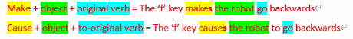

What do the following do? Write sentences using the pattern above:

the mouse makes the cursor move / causes the cursor**s** to move

clicking the ‘maximise’ button ________________________________________________

clicking the ‘x’ button ________________________________________________

a double click on the file icon ________________________________________________

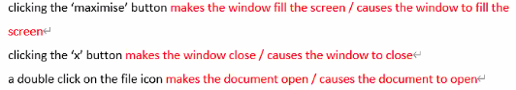

~~Presentations~~

~~Think of three pieces of advice about giving presentations:~~

~~Plan a structure (intro-body-conclusion)~~

~~Don’t read a script / Don’t memorise a script / Practice~~

~~Speak clearly / don’t mumble / don’t speak too fast~~

~~Eye contact~~

~~Gestures / Don’t fidget (make unnecessary movemonts)~~

Read about Double Jam, a company that needs advice about a new website. Read their profile and the two options below and decide which you think is better: 



Listening:

Listen to an IT consultant giving a presentation and answer the questions

1. What is the presentation about?
2. What are her recommendations?

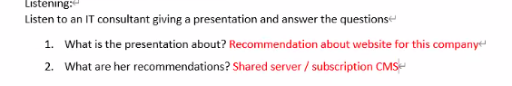

Listen again and complete this table with the English expressions the presenter uses:

|  |  |  |
| --- | --- | --- |
| Part | Expressions in presentation | Your ideas |
| Introduction | *first, I’ll give…* |  |
| Body |  |  |
| Conclusion |  |  |

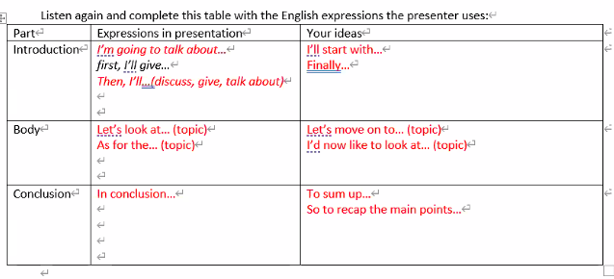

Systems Administrator

What does a systems administrator do?

Responsible for the whole computer system and networks/ general maintaining / making everything is working fine

Complete the table:

|  |
| --- |
| deploys new software / looks after network security / sets up user accounts / works on a help desk  designs databases / updates software across an organisation / writes software to sell to other companies |

|  |  |
| --- | --- |
| A systems administrator’s task | Not a systems administrator’s task |
|  |  |

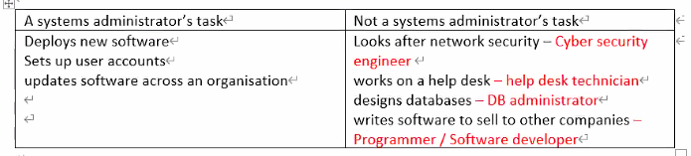

For each task in the right column, what is the correct job title?

Listening:

1. Is it a small company? How do you know? No – because there are many departments
2. What SIX topics does the first man ask Kevin about? Software upgrade / Backups / New staff members / Improving security / Checking logs / Any other problems

Listen again and check the correct column. If there was a problem, what was it?

|  |  |  |  |
| --- | --- | --- | --- |
|  | Worked fine | Problem found | Not mentioned |
| 1. Deploy new software upgrades |  |  |  |
| 1. Deploy new software applications |  |  |  |
| 1. Backup systems |  |  |  |
| 1. Disk drives |  |  |  |
| 1. Set permissions |  |  |  |
| 1. Check logs |  |  |  |
| 1. Reset passwords |  |  |  |

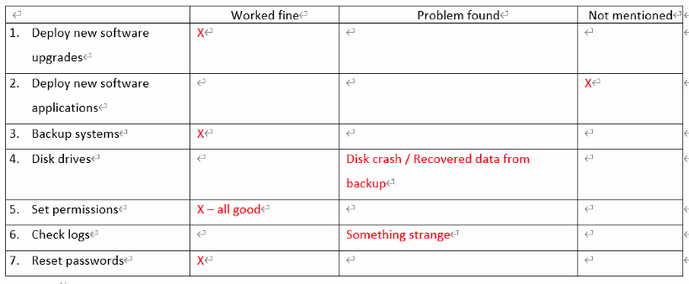 Find words from the table which match these definitions:

1. Change; set again: reset
2. Install on many computers at the same time: deploy
3. Settings on a computer, file or folder that say who can use it: permissions
4. Data that a program or computer produces while it runs, to show how well it is working: logs

~~Complete these phrases:~~

|  |
| --- |
| ~~crash out out of running again smoothly (x2)~~ |

|  |  |
| --- | --- |
| 1. ~~Run smoothly (no problems)~~ 2. ~~Disk crash~~ 3. ~~Be up and running again~~ | 1. ~~Lock (someone) out of (something)~~ 2. ~~Check (something) out (look at)~~ 3. ~~Go smoothly~~ |

**Language 1:**



After you install the OS, train the users // After A, B – First is A

Before you train usrers, install the OS, // Before A,B – First B

Install the OS before you train the users // A before B – First A

Train the users after you install the OS // A after B – First B

After you install the OS, you should train the users = After installing the OS, train the users

After you install the OS, the computer will work faster

Write sentences using *while*, *before* or *after*:

Install the software / do a full backup - *Before installing the software, do a full backup.*

Install an operating system / the computer may reboot several times – While you install an AS, the computer may reboot several times

Deploy major software upgrades / train the users – After deploying major software upgrades, train the users

Replace the hard drive / everything will go smoothly – After you replace the hard drive, everything will go smoothly

Forget a password / reset it – Reset the password after you forget it.

Listen and write which actions should happen first in each case:

|  |  |  |
| --- | --- | --- |
| 1. Email the report 2. Partitioning the hard drive | 3. Checking the schedule  4. getting access | 1. You should ask if it’s ok |

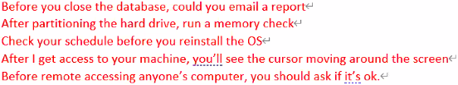

What precautions should you take in these circumstances?

1. Upgrade some software Before you upgrade, you should do a backup
2. Remote access someone’s desktop Before you remote access, you should ask them if it’s ok
3. Switch off a server with users’ computers networked to it sheck the users have saved everything



**Language 2:**

Grammar: Past Continuous

Forms:

|  |  |
| --- | --- |
| Positive | s+was/were + verb-ing  She was cooking |
| Negative | s+was/were + not verb-ing  She was not cooking |
| Question:  Question word  Yes/No answer | q-word(what,where,when) + was/were + S +verb-ing  What was she doing?  Was/were + S + verb-ing  Was she cooking? |

Usage:

To talk about an action in progress at a specific time in the past

* I was installing the software all day yesterday

To talk about an incomplete action that was interrupted by another action

Pattern: Past continuous pattern + when+ past tense verb

* I was installing the software yesterday when the computer crashed
* They were typing there report when i called

To talk about two actions that were happening at the same time

Pattern: Past continuous pattern + while + past continuous

* I was installing the software while they were rasting

Practice 1: Past Simple or Past Continuous

I was exercising (exercise) while my brother was studing (study)

She was downloading (download) a movie when the computer crashed (crash)

Why were you laughing (you / laugh) when I came(come) into the room?

What were you doing (you / do) while I was cleaning (clean) the house?

Were they reading (read) when you called (call)?

Practice 2:

|  |  |
| --- | --- |
| was looking the other way while I was having a bath when my battery died when he crashed I was eating dinner | my wife arrived home when it stopped working when the policeman stopped me I swallowed (삼키다) water when the dog attacked him |

Top of Form

* Tim was driving his car too quickly when he crashed
* my wife arrived home while I was cooking dinner.
* I was riding my bicycle on the footpath when the policeman stopped me
* The boy was delivering newspapers when the dog attacked him
* I was eating dinner when the phone rang.
* My sister was using the computer when it stopped working
* While I was swimming I swallowed (삼키다) water
* Unfortunately, the phone rang while I was having a bath
* I was speaking to my brother on the phone when my battery died
* The thief escaped while the policeman was looking the other way

What Were You Doing?

Ask your partner the following questions. Use the past progressive to answer:

Student A (ask to student B):

What were you doing this time yesterday?

I was eating lunch this time yesterday

-> what were you eating -> i was eating kimbab

What were you doing at 8 o’clock this morning?

What were you doing yesterday at noon?

What were you doing when your phone last rang?

What snack were you eating five years ago?

What were you doing before you went to bed yesterday?

Student B (ask to student A):

What were you doing this time two days ago?

What were you doing before this class?

What were you reading last year?

What were you watching on TV last year?

What were you doing when you last received a kakao message?

What were you watching on TV five years ago?

Web Hosting

1. What is web hosting? Provides storage space and access for websites

2. Using your phones, find and write down 5 web site hosting services.

Bluehost, Hostgator, Dreamhost, A2Hosting, Mochahost

3. What is the number one hosting service according to hostingfacts.com? bluehost

Reading



Find words in the website above which match these definitions:

1. A system where each server has only one client’s websites on it: Dedicated hosting

2. A system where each server has many client’s websites on it: shared hosting

3. Promise to do something: guarantee

4. The time when a service is working: Uptime

5. Help / Assistance: Support

6. The smallest amount or number possible: Minimum

7. The largest amount of data that can be moved: Bandwidth

8. A unique number to identify a computer on the internet: IP Address

Comprehension Questions:

1. What can you do if HostElite’s standard plans aren’t suitable? Send them your specifications
2. What guarantees and support do they provide? 99.99% uptime, 24-7 support, replace, hardware within 24 hours
3. If you set up another website, can you also host that on the same server? Yes - unlimited
4. Can you try them out for a month or two to see how good they are? No – minimum of 6 months
5. How much data can you transfer every month? Between 2TB-25TB

Complete this product comparison for HostElite’s services.

|  |
| --- |
| the most 99.9% the same higher than the most the most less more the best |

The Premier server’s processor is the most powerful of the three. This server has more drives than the Standard server (four instead of two). All have 99.9% uptime guaranteed and they are equally secure. The Basic plan provides more bandwidth than the other two plans, with the Premier plan offering the most bandwidth.

All three plans have the same set-up fees but the monthly fee for the Standard plan is higher than the fee for the Basic plan. Overall, the Premier plan has the best specifications but is the most expensive

~~Listening:~~

~~Listen to two IT officers talking about a host server’s products and answer the questions:~~

1. ~~How many options are they comparing? 3~~
2. ~~If they don’t like any of the options what can the host server do for them? Customise a plan (make a special option for you)~~
3. ~~What does the company do? Music~~
4. ~~How many customers did they have last month? More than 10,000~~

~~Listen again and choose the correct answer~~

1. ~~For this company, $200 per month is not bad~~
   1. ~~cheap b. reasonable c. expensive~~
2. ~~For this company, $500 per month is a bit high~~
   1. ~~cheap b. reasonable c. expensive~~
3. ~~The company is ______________~~
   1. ~~very small b. medium-sized c. large~~
4. ~~The current website size is ______________~~
   1. ~~1 GB b. 1 TB c. 2 TB~~
5. ~~The current monthly bandwidth usage is about ______________~~
   1. ~~1 GB b. 1 TB c. 2 TB~~
6. ~~The company ______________ processing power.~~
   1. ~~doesn’t need much b. needs quite a lot of c. needs a very large amount of~~
7. ~~The company sells to ______________~~
   1. ~~other companies b. consumers~~

~~Research Activity~~

~~On HostGator’s website find the following information:~~

1. ~~How many plans do they have and what are they called? 3, Hatchling / Baby / Business~~
2. ~~How much is the most expensive plan? $5.95/month~~
3. ~~What does ‘unmetered’ bandwidth mean? (Hint: click the link)~~

~~not charged for diskspace or bandwidth.~~

1. ~~How many domain names (website addresses) can you have on the baby plan? Unlimited~~
2. ~~Which plan does HostGator recommend? Baby~~
3. ~~Which plan has a 60% discount? Hatchling / Baby / Business~~
4. ~~Find the “technical specifications” section for the following:~~
   1. ~~How many hosted domains do they have?~~
   2. ~~How many employees do they have?~~
   3. ~~How do they describe their support?~~
   4. ~~What are their two guarantees?~~

IT Costs

Listening

Listen to a manager talking about costs and answer the questions

1. What kind of gadget is she talking about? Digital camera?
2. How did the memory card break? Someone dropped it
3. What do they pay €4.50 a month for? Photo sharing website
4. How much is the total cost per year? €694

Listen again and complete the sentences

1. It cost €1,200 to buy.
2. We spent €45 on some memory cards.
3. That was €35 for a case.
4. We also pay €4.50 a month.
5. We’ll pay €1,388 in total.

~~Speaking:~~

~~Complete the table with a partner~~

~~Number of years: 3~~

|  |  |  |
| --- | --- | --- |
| **~~Item~~** | **~~Samiba DR750~~** | **~~Sundai TB10.6~~** |
| ~~Initial purchase cost~~ |  |  |
| ~~Software costs~~ |  |  |
| ~~Warranty~~ |  |  |
| ~~Technical support costs~~ |  |  |
| ~~Training~~ |  |  |
| ~~Other items (list)~~ |  |  |
| ~~Total cost of ownership~~ |  |  |

Product Research

|  |
| --- |
| ads models price cloud free levels regular version trial minor |

There are several different kinds of pricing models.

Traditional pricing: This is the most common pricing model for consumer software. Each major version of the software costs money, minor versions are free for people with a licence. When a new major version comes out, licence holders pay extra but usually less than for a non-licence holder. Users can often try the software for free for a short trial period.

Tiered pricing: In this model there are two or three levels (tiers) of the software product. Each level has a different price and different features.

Freemium pricing: This is like tiered pricing but the lowest level is free. The idea is that the free users will get others (like companies) to use it.

Subscription pricing: In this the buyer pays a regular fee, usually every month, to use the software. This fee includes all updates. This is usually used in cloud computing.

Freeware: This is free software. It might have a lot of ads.

~~Listening: Which pricing model is described by each salesperson?~~

~~1. ____________ pricing~~

~~2. ____________ pricing~~

~~3. ____________ pricing~~

~~Scanning Activity: Look at Norton’s choice of the 8 most famous viruses and answer the questions~~

1. ~~What percent of emails were infected with MyDoom? 16~25%~~
2. ~~When was CryptoLocker first released? 9m 2013y~~
3. ~~What happened to the creator of the Anna Kournikova virus?~~

~~He turned himself into the police / he was offered a job~~

1. ~~How does the article describe Stuxnet? The scariest virus on the list.~~
2. ~~What was the name of the attachment in the ILOVEYOU virus?~~

~~LOVE-LETTER-FOR-YOU.TXT.vbs~~

1. ~~What kind of malware was Storm Worm? (Not virus or worm) Trojan horse~~
2. ~~What is the “Cost of the Malware” for the Slammer virus? $1 billion.~~
3. ~~What is the 5~~~~th~~ ~~most famous virus on the list? Sasser & Netsky~~





activity

1. What are the first 5 websites in your web history? (Ask your partner some questions about these)

2. Which browsers do you use? Which is your favourite? Why?

3. Which device do you mainly use to surf the internet?

4. Do you ever listen to podcasts? What was the last podcast you listened to about?

5. Would you prefer to read a paper book or an e-book? What was the last e-book you read?

Task:

Have a conversation with a partner

using the questions

All in English

Ask follow up questions!

* two Zoom page, google : It's good to have a lot of information, ~~~

**Data Communication**

~~Match verbs with nouns to make collocations:~~

|  |  |
| --- | --- |
| 1. ~~Follow H~~ 2. ~~Take part in d~~ 3. ~~Stream a, d~~ 4. ~~Update c, f~~ 5. ~~Post a, e, g~~ 6. ~~Download a, d, e~~ 7. ~~Browse f, e~~ 8. ~~Enter b~~ | 1. ~~Video~~ 2. ~~A password~~ 3. ~~Your status~~ 4. ~~A webinar (a web seminar)~~ 5. ~~Photos~~ 6. ~~Web pages~~ 7. ~~A comment~~ 8. ~~A link~~ |

~~Listen and answer:~~

1. ~~Does the IT specialist help the customer solve his problem? yes~~
2. ~~What does the caller like about the new browser? He can see all the bookmarks~~

~~Listen again:~~

1. ~~What IT has changed in the company?~~
2. ~~What three things does the caller need help with?~~
3. ~~Where are the menus?~~

Web Addresses:

|  |  |  |
| --- | --- | --- |
| Dash  Dot  Equals | Backslash  Forward slash | Question mark  Underscore |

시험나옴

**What is a Network?**

|  |
| --- |
| area / network / server / wireless / client-server / local / address / wide / connection / browser |

A network is a group of linked computers or other devices. There are two kinds of networks that are in common use.

In local area Networks (LANs) computers are close together – perhaps in the same building. They might be connected directly to each other by cable or through a wireless network such as wi-fi. In contrast, wide area networks (WANs) cover a larger area and usually use telephone lines or a mobile phone system to connect. A LAN can be a part of a WAN.

There are different types of wired networks. ***One*** is a star system. In ***this***, each computer (or other device) is connected to a central server. ***Another type*** is a ring system. This is a network that has each computer linked to two others. In a bus system there is a central cable which is called a bus, and each computer is linked to ***it***. Some large networks use a mesh. In ***this***, each computer is linked to several others. ***This*** has one big advantage: if one connection breaks, the data can use other connections. Therefore, it is difficult to break a mesh network.

Many networks work on a client-server system. In this, servers are special computers that store data, serve websites and have other similar functions. Generally, a client program will ask the server for data and the server will then send the data back to the client. For example, when you type a web address into a browser, the browser (the client) will ask the server for a web page, which then sends the web page back.





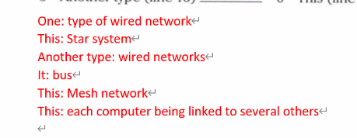

Label the diagrams:



1. **Ring**
2. **Star**
3. **Mesh**
4. **bus**

**Mobile Computing**

~~Complete the flowchart:~~

1. ~~Admin staff (Office workers) print out work instructions => 1~~
2. ~~Admin staff send invoice (paper showing cost of something) asking for payment => 6~~
3. ~~Client signs paperwork => 4~~
4. ~~Technician finds client and installs system => 3~~
5. ~~Technician picks up instructions => 2~~
6. ~~Technician takes paperwork back to office => 5~~

~~~~

~~How will the above flowchart change if the technician has a mobile device? Listen and draw a new flowchart to record this situation.~~

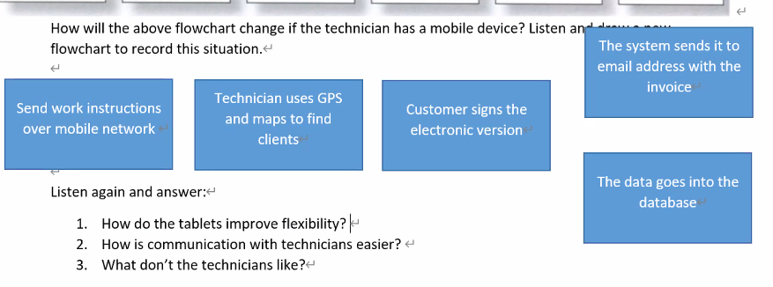

~~Listen again and answer:~~

1. ~~How do the tablets improve flexibility? If a customer changes their order, they can tell the technician easily~~
2. ~~How is communication with technicians easier? If they need spare parts, they order directly~~
3. ~~What don’t the technicians like? ~~

|  |
| --- |
| Language: Zero Conditional  Review: First conditional is used to talk about future results:  Pattern**:** If + present simple, will + (original) verb  If you click on this icon, a window will appear.  The zero conditional is used to talk about something that **usually** or **always happens** as a result of an action or situation. It describes **facts**.  Pattern**:** If /When+ present simple, present simple  If you drop a tablet, it breaks / First conditional : If you drop a table, it will break.  If you use a tablet, you can send documents easily. |

If/When:

If: the situation may or may not happen

When: the situation is expected / the situation will probably happen

When I get 100% on a test, I ~~will~~ eat 삼겹살

~~If~~ / when the sun rises, the alarm goes off

If you want to use the computer for a long time, clean the computer regularly.

A

Zero Conditional Practice

1. if / wild / are / scared / . / bite / they / animals

_____________________________________________________

1. if / get / too / eat / much / , / you / . / you / fat

_____________________________________________________

1. if / beach / go / . / the / sunscreen / should / you / to / you / take

_____________________________________________________

1. if / doesn't / oxygen (O2) / burn / no / paper / there / . / is

_____________________________________________________

1. if / big / need / . / you / a / have / family / , / you / a / car / big

_____________________________________________________

Complete the following assuming the entertainment system installation company uses mobile devices:

1. With the tablets, if the technician _________ (not know) the way to a job, he or she _________ (use) GPS to find the best way there.
2. If the customer ___________ (be) happy with the job, he or she ___________ (sign) using the tablet’s screen.
3. If a customer ___________ (change) their order, the system ____________ (update) the details on the tablet.
4. If a technician ___________ to order a new part, he or she ___________ a message electronically.

Zero Conditional Quiz

1. What do you do when you wake up late?

_____________________________________________________

1. What do you do if your internet doesn’t work?

_____________________________________________________

1. What do you do when you feel a cold starting?

_____________________________________________________

1. What do you do if you need to wake up early?

_____________________________________________________

1. What do you do if you are bored?

_____________________________________________________

1. What do you do when you can’t sleep at night?

_____________________________________________________

1. ____________________________________

_____________________________________________________

1. ____________________________________

_____________________________________________________

1. ____________________________________

_____________________________________________________

Discussion Questions (Internet)

1. What are 3 interesting websites you have bookmarked? (Ask your partner some questions about these)
2. Which browsers do you use? Which is your favourite? Why?
3. Which device do you mainly use to surf the internet?
4. Do you ever listen to podcasts? What was the last podcast you listened to about?
5. Would you prefer to read a paper book or an e-book? What was the last e-book you read?